**Analysis of Entrance Exam Performance and Its Impact on College Subject Performance**

### **Objective**

The purpose of this analysis is to determine whether students who excelled in entrance-based subjects (Mathematics, Physics, Chemistry) continue to perform better in college courses that are conceptually related to their entrance subjects (Math-1, Physics, Math-2, and Fundamentals of Electronics and Electrical Theory). Furthermore, we compare their performance in these subjects to their performance in technical subjects (Java-1, Data Structures, DBMS, and Java-2) to assess whether the performance gap has diminished.

### **Methodology**

1. **Data Extraction:**
   * The dataset used for this analysis is college.csv, which contains student performance data.
   * The department of each student is identified using the Div-1 column, where the first character represents the department (A, B, or D).
   * The internal roll number within each department is extracted from the Roll-1 column.
2. **Performance Calculation:**
   * **Entrance Rank Percentile** is calculated using the Roll-1 column by ranking students within their department.
   * **12th-Based Performance** is computed as the average of:
     + Math-1 Theory
     + Physics Theory
     + Math-2 Theory
     + Fundamentals of Electronics and Electrical Theory
   * **Technical Performance** is computed as the average of:
     + Java-1 Theory
     + Data Structures using Java Theory
     + DBMS Theory
     + Java-2 Theory
   * Percentiles are determined for both **12th-Based Performance** and **Technical Performance** by ranking the respective averages within the department.
3. **Analysis and Visualization:**
   * Scatter plots with regression lines are generated for each department (A, B, and D):
     + **Entrance Rank Percentile vs. 12th-Based Subject Performance Percentile**
     + **Entrance Rank Percentile vs. Technical Subject Performance Percentile**
   * The regression equations and correlation coefficients are recorded for interpretation.

### **Results and Interpretation**

* The regression equations and correlation coefficients (r-values) provide insight into the relationship between entrance exam performance and college subject performance.

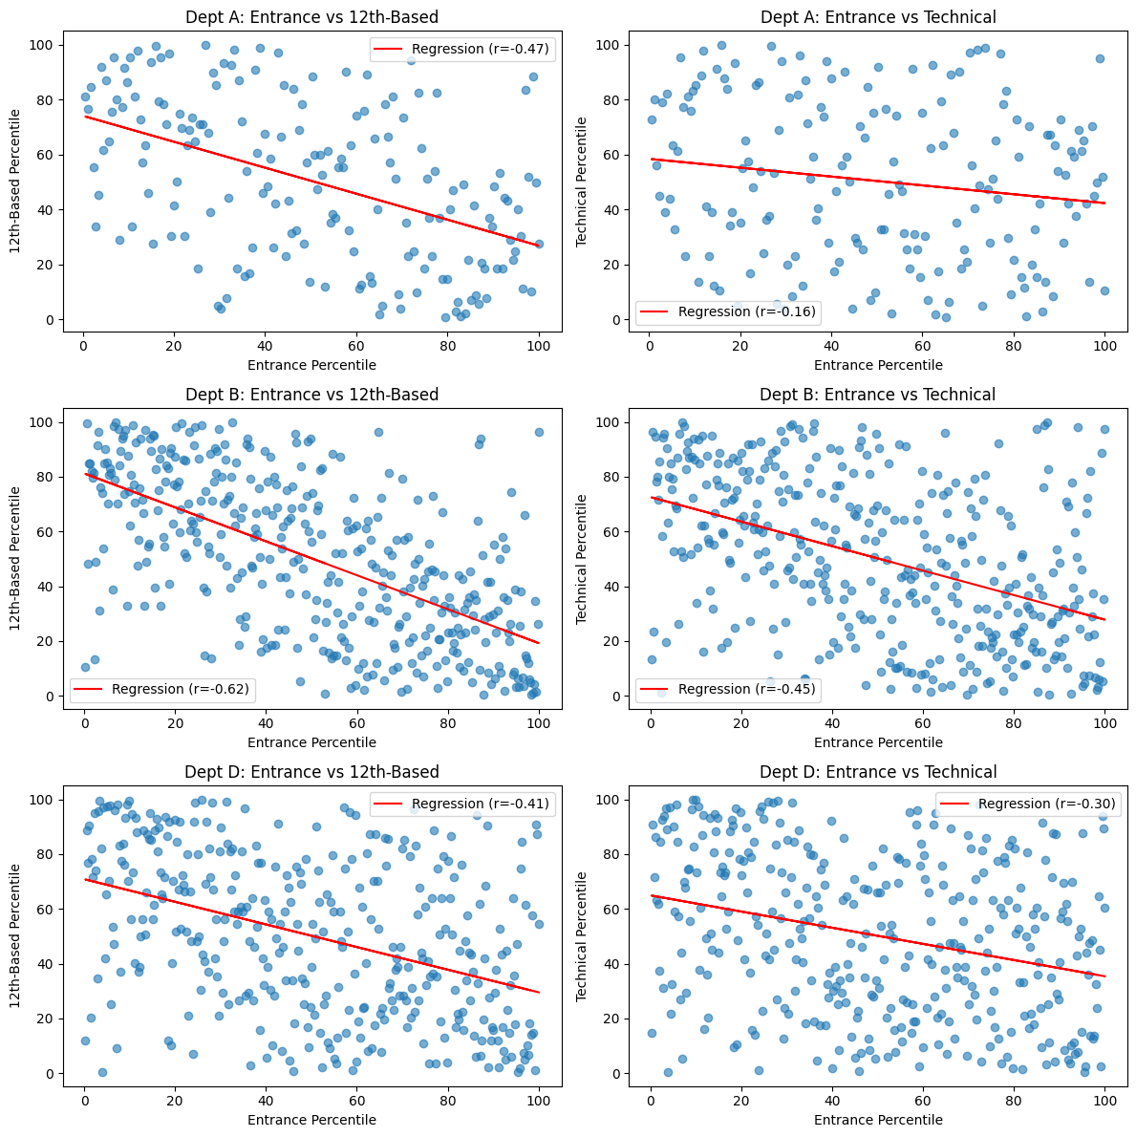

* The department-wise regression results are as follows:  
  + **Dept A (12th-Based):** y = -0.47x + 74.06, r = -0.47
  + **Dept A (Technical):** y = -0.16x + 58.38, r = -0.16
  + **Dept B (12th-Based):** y = -0.62x + 81.19, r = -0.62
  + **Dept B (Technical):** y = -0.45x + 72.57, r = -0.45
  + **Dept D (12th-Based):** y = -0.41x + 70.86, r = -0.41
  + **Dept D (Technical):** y = -0.30x + 64.95, r = -0.30
* Department B, which corresponds to the **CSE course**, had a higher cutoff than other courses. This could explain why its **12th-Based regression (r = -0.62)** is the highest among all departments, as only the top-scoring students were accepted into the course.
* The negative slope values across all regressions indicate an inverse relationship between entrance percentile (lower values indicate better ranks) and performance percentiles, implying that students who secured better ranks in entrance exams tend to perform well in both subject categories.
* However, the correlation is notably stronger for **12th-Based subjects** across all departments, indicating that students who were strong in entrance exam subjects continue to excel in related college subjects.
* The correlation with **technical subjects** is slightly weaker in all cases, suggesting that while entrance exam performance is still a factor, additional skills and learning curves may play a role in technical subject mastery.

### **Implications**

* The findings suggest that entrance exam ranks are a reliable indicator of academic success in 12th-based subjects but are slightly less predictive for technical subjects.
* The relatively lower correlation in technical subjects could imply that these subjects require different skill sets that are not entirely captured by entrance exam performance.
* For educators and policymakers, this may indicate the need for bridging courses or preparatory modules to help students transition effectively into technical subjects.
* Future research could explore additional factors such as study habits, practical assessments, and cognitive skill differences that might contribute to success in technical subjects.